【例4-65】剪切图像
I = imread('ic.tif');
I2 = imcrop(I,[60 40 100 90]);
imshow(I)
figure, imshow(I2)
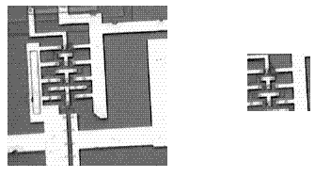
图像的剪切

